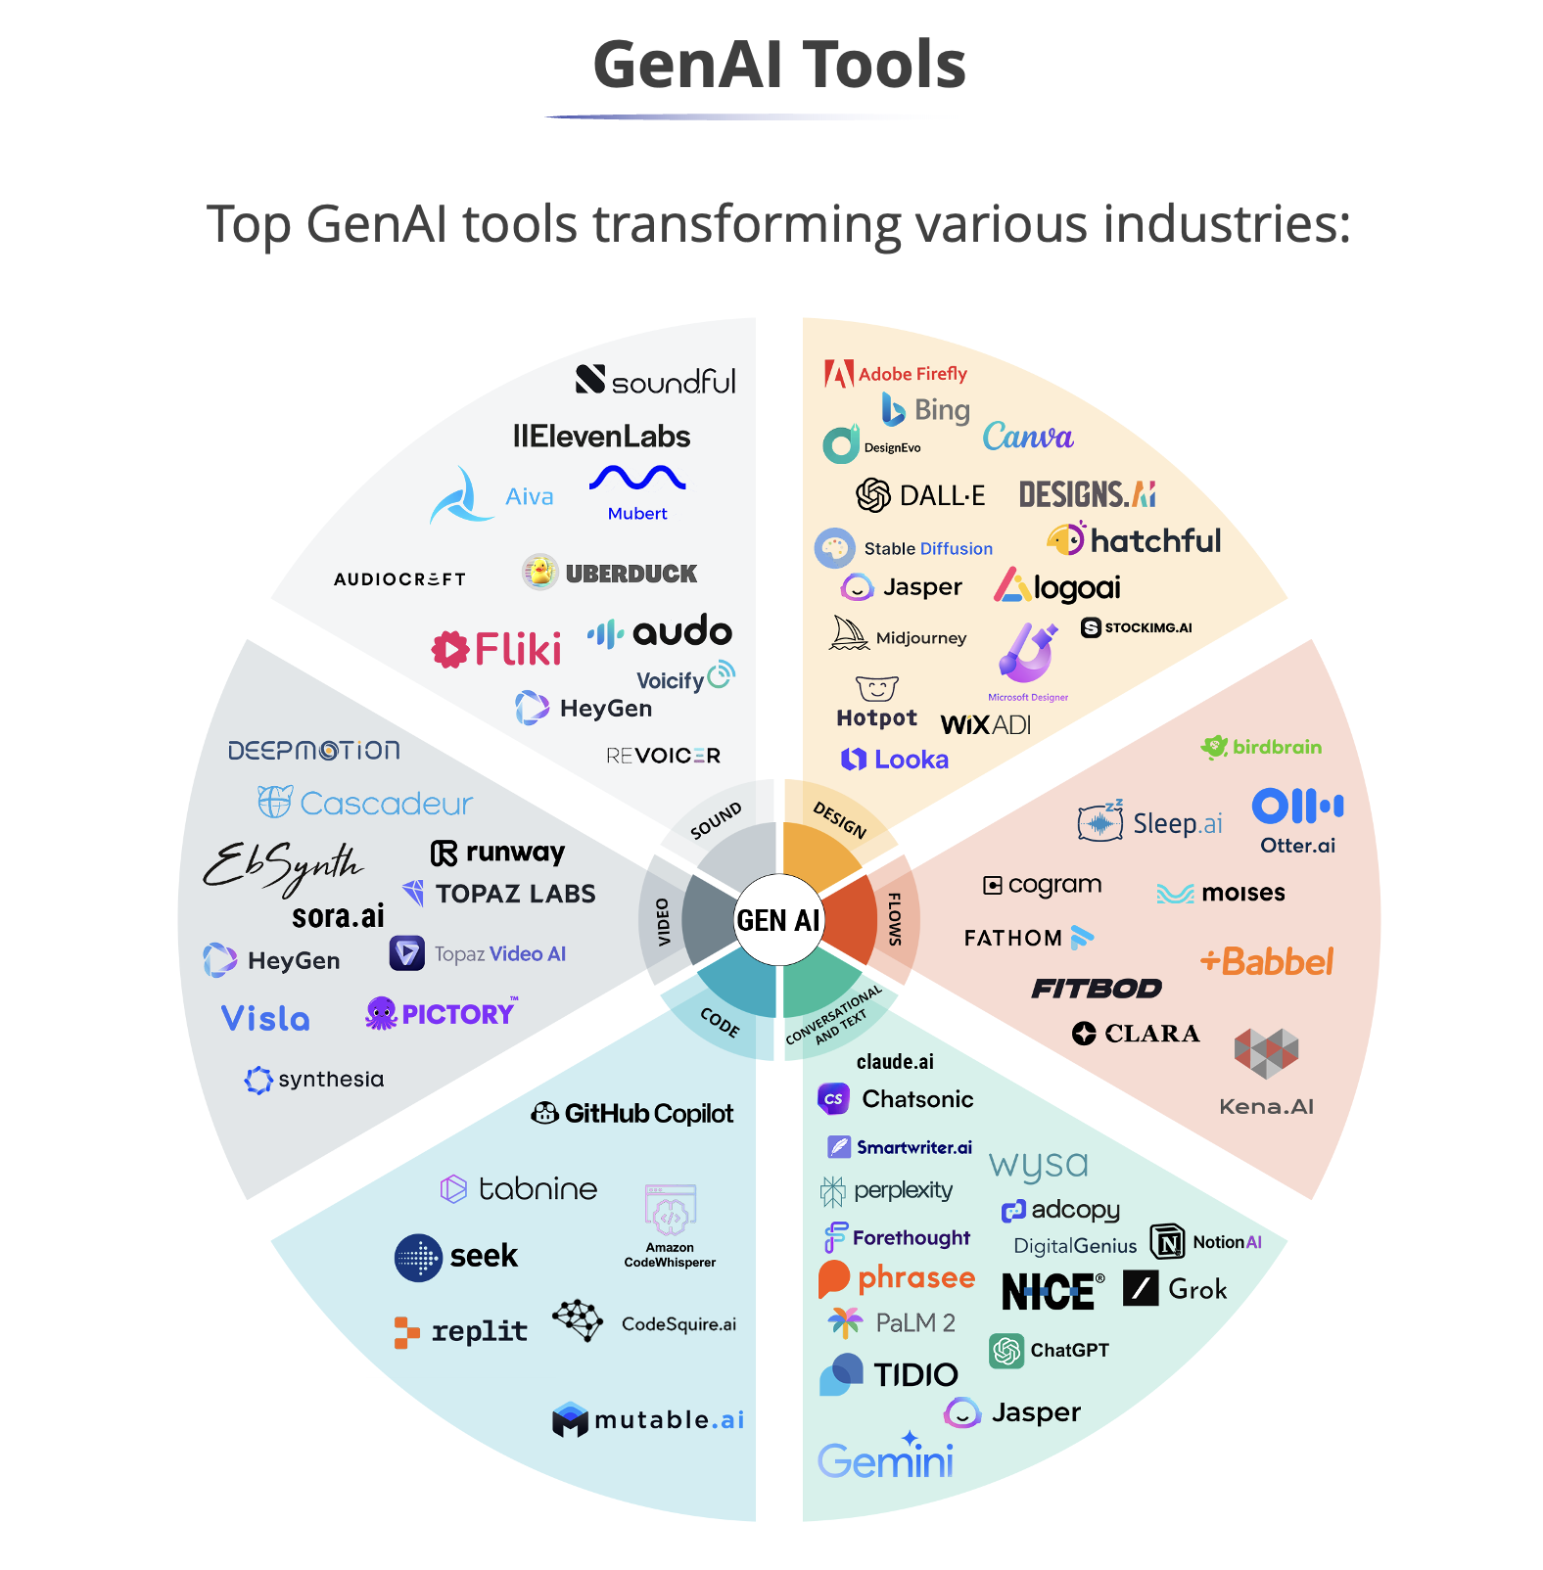

Adobe Firefly – Image and video generation for creative design. (e.g., generating a poster instantly in Photoshop)
Bing + ChatGPT – AI-powered search + conversation. (e.g., ask Bing “summarize today’s news”)
Canva – AI-assisted graphic and presentation design. (e.g., create a LinkedIn post in 30 seconds)
DALL·E – Image generation from text prompts. (e.g., “A futuristic Mumbai skyline in watercolor style”)
Designs.ai – Marketing content automation. (e.g., instantly generate a brand logo and ad copy)
Jasper – AI writing assistant for business. (e.g., draft sales emails or blogs)
Logoai – Automated logo creation. (e.g., generate a startup logo in seconds)
Soundful / ElevenLabs / Aiva – Music and voice synthesis. (e.g., generate background music for a YouTube video)
Synthesia – AI video avatars. (e.g., CEO video message without recording)
Runway / Pictory / Topaz Labs – Video editing with AI. (e.g., remove objects or upscale video quality)
Visla / HeyGen – AI-driven video creation. (e.g., convert blog into a narrated video)
GitHub Copilot / Replit / Tabnine – AI coding assistants. (e.g., autocomplete Python functions while coding)
Claude / ChatGPT / Gemini / Grok – Conversational LLMs. (e.g., customer support chatbots)
Tome / Beautiful.ai – AI for presentations. (e.g., generate a PowerPoint deck from text notes)
Wysa / Replika – Mental health chatbots. (e.g., AI companion for stress management)
Otter.ai / Fireflies.ai – Meeting transcription. (e.g., generate meeting notes automatically in Zoom)
Notion AI – Productivity + note-taking automation. (e.g., summarize project notes)
Perplexity.ai – Research-focused conversational search. (e.g., ask “Compare Tesla vs Rivian EV strategy”)
DeepBrain / HourOne – AI-generated presenters. (e.g., virtual anchor reading your script)
Stable Diffusion / MidJourney – High-quality text-to-image. (e.g., design an architectural concept art)
QuillBot – AI-powered writing improvement. (e.g., paraphrase a paragraph for clarity)
GrammarlyGO – AI writing assistant. (e.g., refine tone of emails)
Copy.ai – Marketing content generation. (e.g., social media ad captions)
Looka – Brand kit & logo builder. (e.g., generate an entire brand style guide)
Synthflow – No-code AI app builder. (e.g., build a custom chatbot without coding)
Cogram / Moises / Sleep.ai – Productivity and health AI. (e.g., isolate vocals from songs in Moises)
Babbel / Duolingo – AI-driven language learning. (e.g., practice French via chatbot)
Fitbod / Olive AI – Fitness & healthcare AI. (e.g., personalized gym workout plans)
Lattice / Seek AI – HR and recruitment AI. (e.g., auto-screen resumes)
Fathom – Meeting insights. (e.g., highlight key decisions in Zoom call)

